……………………….. English Title(Capital Letter)…………………… …..
………………………….. Thai Title……..………………..
(Times New Roman 15 pt / Bold)

Full name-Last name (First author)^{1*}, Full name-Last name (Co-author)²
(Times New Roman 13 pt /Bold)

¹ Institution (First author) (Faculty, University)
² Institution (Co-author) (Faculty, University)
*Corresponding author, E-mail: …………
(only the primary responsible person’s email is required, please mark * after the primary responsible person’s last name)

Abstract (Times New Roman 12 / Bold)
Abstracts should be short, concise, to the point, and comprehensive. The length should not exceed half an A4 page. (The first line of the paragraph is one strip away from the left edge of the paper (Tab) and aligned to the left edge of the paper. when starting a new line /Times New Roman 12 pt.)

Keywords: Should be 3-5 words by tapping 1 time when there are more than 1 important word and using a “,” separator (using a capital letter at the beginning of each word) (Times New Roman 12 pt.)

Introduction (Times New Roman 12 / Bold)
The first line of the paragraph is one strip away from the left edge of the paper and aligned with the left edge of the paper when starting a new line (Times New Roman 12 pt.) …………………………………………………………………………………………………………………………………………...………………………..
……………………………………………………………………………………………………………………………………………………………………..

Literature Review (Times New Roman 12 / Bold)
The first line of the paragraph is one strip away from the left edge of the paper and aligned with the left edge of the paper when starting a new line (Times New Roman 12 pt.) …………………………………………………………………………………………………………………………………………...………………………..

Objectives (Times New Roman 12 / Bold)
The first line of the paragraph is one strip away from the left edge of the paper and aligned with the left edge of the paper when starting a new line (Times New Roman 12 pt.) …………………………………………………………………………………………………………………………………………...………………………..
……………………………………………………………………………………………………………………………………………………………………..

Conceptual Framework
(Specify the conceptual framework of the research and the theory Concepts used to create conceptual frameworks and assumptions (if any))

Methodology (Times New Roman 12 / Bold)

The first line of the paragraph is one strip away from the left edge of the paper and aligned with the left edge of the paper when starting a new line (Times New Roman 12 pt.) …………………………………………………………………………………………………………………………………………...………………………..

Results (Times New Roman 12 / Bold)

The first line of the paragraph is one strip away from the left edge of the paper and aligned with the left edge of the paper when starting a new line (Times New Roman 12 pt.) …………………………………………………………………………………………………………………………………………...………………………..

Table 1 Table name.............(Times New Roman 12).....
Table Header | Table Header | Table Header | Table Header
Table  Table  Table  Table | Table  Table  Table  Table | Table  Table  Table  Table | Table  Table  Table  Table
 | Table | Table | Table
Source: (If any)……………(Times New Roman 12)

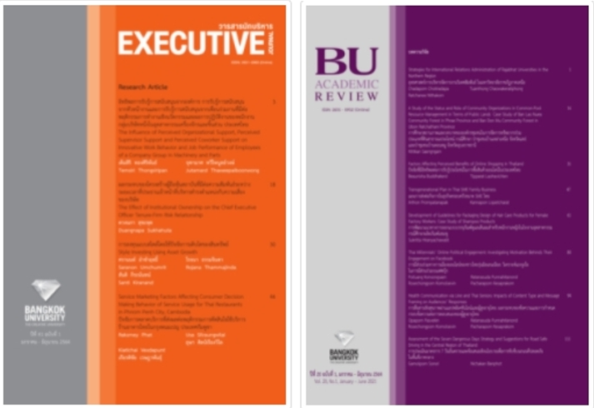
Picture 1 Picture name / Chart name.....(Times New Roman 12)............
Source: (If someone else's picture or table is cited, please include the source. to prevent copyright infringement)……………(Times New Roman 12)

Discussion (Times New Roman 12 / Bold)
The first line of the paragraph is one strip away from the left edge of the paper and aligned with the left edge of the paper when starting a new line (Times New Roman 12 pt.) …………………………………………………………………………………………………………………………………………...………………………..

Conclusions and Implications (Times New Roman 12 / Bold)
The first line of the paragraph is one strip away from the left edge of the paper and aligned with the left edge of the paper when starting a new line (Times New Roman 12 pt.) …………………………………………………………………………………………………………………………………………...………………………..
……………………………………………………………………………………………………………………………………………………………………..

References (Times New Roman 12 / Bold)
Sorted by author's name in English alphabetical order (Times New Roman 12 pt.) …………………………………………………………………………………………………………………………………………...…………………………………………………………………………………………………………………………………………………………………

Writing a list of references at the end of the article (more details can be found at Reference writing style files in the text and reference material) There are guidelines as follows.
1. Do not have numbers but put them in alphabetical order by author's name Start with Thai followed by English.
2. All references must be referenced or mentioned in the article. References in articles use the noun-year system, APA Style 7th format. Citations, if any, in the text. The end of the article must be there as well.
3. Reference documents must not exceed 20 items and should not be older than 10 years.

